Authorization for the purchase of a FlowJo seat license
FlowJo is one of the most popular platforms to analyze flow cytometry data. Like many other software platforms in science, it is constantly getting updates to grow along with the field. Although you can purchase a dongle for using FlowJo, most institutions now utilize FlowJo’s licensing server.

Some basic points about how billing works:

- For the 2016/2017 FY NSU has purchased the 25 seat license package. This can be amended upward should we get more users. More users mean cheaper yearly prices. Current yearly price is: 690$/yr

- Purchasing options:

- Online

- Computer MUST have internet access to use the program
- If computer does not launch FlowJo in a given Quarter, that computer will not be charged.
- This option is probably better for computers that will have access to internet at all times (ie lab computers)
- Offline

- Computer does NOT have to have internet access to use the program
- Computer is charged the yearly rate regardless of how much FlowJo is used.
- This option is better for computers that may have limited access to internet at time (ie laptops that travel).
- How to access FlowJo:
- 2 Computer analysis stations in the Flow Core- FlowJo will loaded onto both a PC and a Mac in the Flow Core, and can be used for a nominal hourly fee (5$/hr).

- Fill out and submit this form.
- User will be added/authorized to book time on the Flow Core Calendar for the analysis computers.

- FlowJo loaded onto the USERs own computer

- Download FlowJo for your computer start FlowJo and write down your hardware address

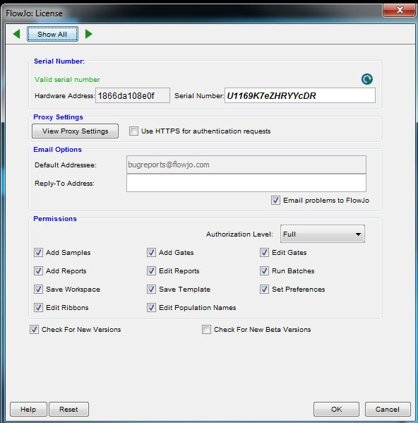

- Fill out and submit this form.
- Flow Core manager will register your computer with FlowJo, and send you the serial number.

Fill out the parts of the form that pertain to how you wish to use FlowJo

Please check all that apply:
☐ Use NSU Flow Core computer analysis stations (5$/hr)
☐ Purchase ONLINE FlowJo (up to 690$/yr)
☐ Purchase OFFLINE FlowJo (690$/yr)

All users please fill out the following:
First Name: Click or tap here to enter text.
Last Name: Click or tap here to enter text.
Phone: Click or tap here to enter text.
Email: Click or tap here to enter text.
Lab PI: Click or tap here to enter text.

If purchasing an online/offline FlowJo license, please also fill out the following:
Computer Hardware Address: Click or tap here to enter text.
Assigned Computer Name: Click or tap here to enter text.

PI Authorization

PI Name: Click or tap here to enter text.
PI Email: Click or tap here to enter text.
NSU Account number for billing: Click or tap here to enter text.
PI Electronic Signature: Click or tap here to enter text.
☐ I understand that checking this box constitutes a legal signature confirming that I acknowledge and agree to the charges for the use of FlowJo by the USER.

